9 Way Schuko(™) 16A EU Fitted Plug Power Distribution Unit (PDU) for Server Cabinets and Data Centers Multi Plug Power Strip, 1.8M Cable. for Horizontal Placement in Data or Server Racks

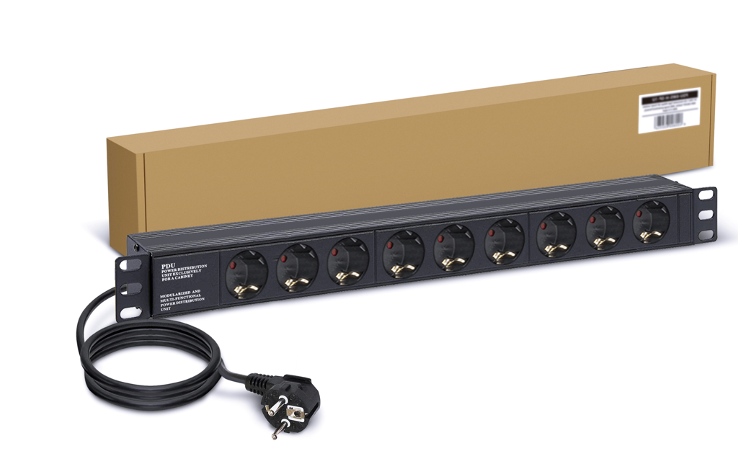
Derzeit nicht verfügbar.
Ob und wann dieser Artikel wieder vorrätig sein wird, ist unbekannt.
- 🔌 CONVENIENCE & SPACE-SAVING DESIGN ↪ Ideal for your home, office, entertainment center or any room with multiple electronic devices, the Dynamode PDU Surge Protected Extension Lead has a slender, space-saving design. Ideal for vertical placement in data or server enclosures with 1.8 meter (approx.) power cable for maximum comfort.
- 🔌 HEAVY-DUTY 1.8-METER POWER CORD ↪ Protect your connected devices by keeping them out of the way thanks to a 1.8 meter extension cable.
- 🔌 QUALITY MADE FOR YOU ↪ Dynamode PDU is made only from the best quality aluminum Alloy construction. Our design includes plug mount rack. For your maximum control and comfort Neon Illumination indicators. Power Switch cover added.
- 🔌 9-WAY EU PLUG-SOCKET STYLE ↪ Dynamode Extension Plug turns a single socket mains outlet into a 9-way socket extension. 16-amp EU socket output. Ideal for LAN, audio-visual, PBX, VoIP and CCTV applications.
- 🔌 VERIFIED SAFETY ↪ certified by CE & FCC & RoHS. The Dynamode allows all the 9 sockets port simultaneously works without a break.

Produktinformation
- Verpackungsabmessungen ‏ : ‎ 18.8 x 0.94 x 0.74 cm; 1.7 Kilogramm
- Im Angebot von Amazon.de seit ‏ : ‎ 16. November 2021
- Hersteller ‏ : ‎ LMS Data
- ASIN ‏ : ‎ B09DLCNGTS
- Herstellerreferenz ‏ : ‎ PDU-9W-H-SCH-SCH-FBM

Produktbeschreibungen
Looking for high-performance power distribution for your heavily loaded systems?
The LMS Data 16A heavy-duty horizontal rack-mount PDU is ideal for high-loading device requirements including server, network and other industrial-type equipment functions such as broadcast and HVAC applications, plus ideal for EU/European AC power applications.
Combining a fully certified Schuko(tm) 16A plug input with a compatible heavy load power flex means you can be assured this LMS Data PDU can work without problems, 24/7.
With a horizontal form-factor and standard Schuko(tm) sockets, allowing for safe and secure electrical power feeds to your high power devices.
Robust in design, the LMS Data PDU is designed to deliver maximum electrical power today and tomorrow.
The newly developed Dynamode 1U heavy-duty horizontal PDU using the modular 16-amp EU socket output which is ideal for many device requirements including server, network and other industrial-type equipment functions such as broadcast and HVAC applications.

Specifications:
- Horizontal
- High-density Power Distribution Unit (PDU)
- Compatible, Heavy-load Power Cable
- Robust, Black Aluminium Design for Industrial Use
- Assured Control
- 1.8 Metre (approx.) Power Cordage for maximum comfort
- Ideal for LAN, audio-visual, PBX, VoIP and CCTV applications

